Accelerometer and Gyro Sensor

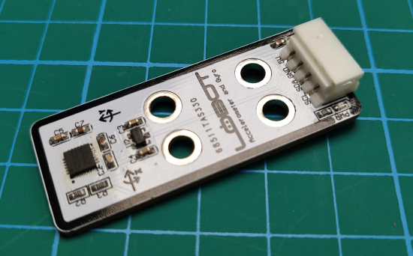

Parameter list

|  |  |
| --- | --- |
| VCC | External connection for 5 v |
| GND | External connection for GND |
| SDA | SDA |
| SCL | SCL |
| PCB size | 50mm*20mm |
| Connector type | 5264 |